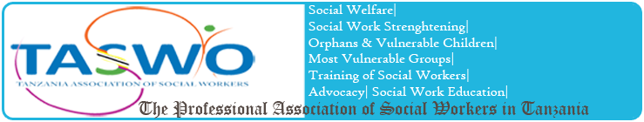

TASWO KILIMANJARO | ACTIVITY PLAN AND BUDGET


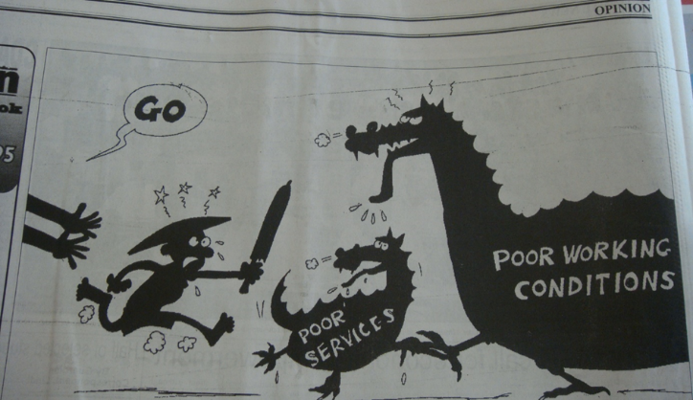
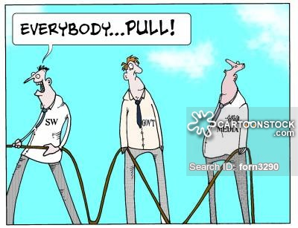
A BRIEF NARRATIVE ON TASWO K PROPOSED PLANS FOR 2018

Introduction
This plan presents an intention or decisions of the Board about what TASWO K is going to within the next one year from January 2018 to December 2018. It briefly explains why the proposed activities are worthy implemented for the growth of Social Work Profession in Kilimanjaro Region. The proposed budget line for each activity is attached with this plan. The following are planned activities for the 2018:-

Marking World Social Work Day
World Social Work Day will be on the 20th March 2018. It is the key day in the year that social workers worldwide stand together to celebrate the achievements of the profession and take the theme message into their communities, workplaces and to their governments to raise awareness of the social work contributions and need for further action. It involves visiting a social group or an institution and learn, but also provide support to the needy.
- International Social Work Conference in Rwanda
The International Social Work Conference on Professional Social Work and Sustainable Development in Africa is scheduled for 20th to 22nd 2018 in Kigali Rwanda. In light of the lessons learned in the 2017 Zambia Conference, particularly strengthening the regional networking and partnership, TASWO K considers this conference as equally important and necessary platform for this noble course. TASWO K is therefore, planning to send a delegation of Six (6) representatives of which Two (2) will be students from Mwenge Catholic University and Kisangara Institute of Social Welfare.
- Norway Visit
It has been a good tradition enshrined in the Memorandum of understanding (MoU) between TASWO K and FO for both parties have cordial visits. In light of the MoU, TASWO K envisages to send its representatives to Norway. The number will so depends on the budget available.

General Meeting and Annual General Meeting
- The General meeting (GM) is normally in April, and the Annual General Meeting (AGM) in November each year. The GM is designed for social workers to meet, discuss and share work place challenges. In 2018, we are planning to organize a Training Workshop for Social Work Career Development.
- The Annual General Meeting (AGM) is the members’ supreme meeting. The platform is meant only for TASWO K actives members. The AGM offers an avenue for leaders to give feedback on the implementation of the planned activities, financial accountability of the year in question and members’ approval of TASWO K future plans.
- National Annual General Meeting (AGM) in Kilimanjaro
The National AGM for 2018 and 2019 shall be held in Kilimanjaro Region. The decision was reached at the National AGM in Dodoma this year due to outstanding performance. TASWO K is therefore expected to host the national delegations of over 300 participants. To make this meeting a success, the Board would have to coordinate through consultative meeting with the TASWO Headquarters and other stakeholders in the region. This too, will require both time and financial resources.
- Recruitment of New members
This is an ongoing activity for TASWO K. Each year TASWO K recruits new members either from the students’ fraternity or from social workers entering the labor market. The 2018 recruitment target will be on students, whom we hold much trust that if recruited, and nurtured, they will make TASWO strong and sustainable. We shall also visit Non Governmental Organizations, Public and Private Institutions employing Social Workers in all Seven (7) districts of Kilimanjaro Region.

TASWO K involvement in marking National and International events
TASWO K plans to commemorate World Labour Day on 1st May, 2018. As a Professional association, TASWO K has interest on its members working in different wok setting in the Kilimanjaro region. We shall use the event to do lobbying and advocacy to politicians and policy makers, as well as recruiting new members. The Legal aid service day shall also be used on similar goals.
- T-shirts project
TASWO K in collaboration with TASWO HQ wishes to use the occasion of the national AGM in 2018 to maximize our income generating activities. These will include, among others printing branded T-shirts, diaries and pens for the conference participants.

Communication
In order for TASWO K leaders to manage the planned activities, it is necessary to communicate either though phone calls or internet services. This requires air time and internet bundles.
- Stationeries and office supplies
TASWO is growing, and now that we have an office, the need for office supplies and stationary is becoming very evident. TASWO K plans to use members’ subscriptions and contributions to buy an office computer and printer.

Conclusion
TASWO K believes that the implementation of the proposed activities will not only make the association visible but also make it professionally relevant to both members and the society. We wish to reiterate our appreciations on the partnership between FO and TASWO K, particularly, the financial support. You have helped us grow. We are therefore, looking forward to continue working with you in 2018 and in many years to come.

