TASWO – KILIMANJARO | ACTIVITY REPORT JAN 2019-DEC 2019
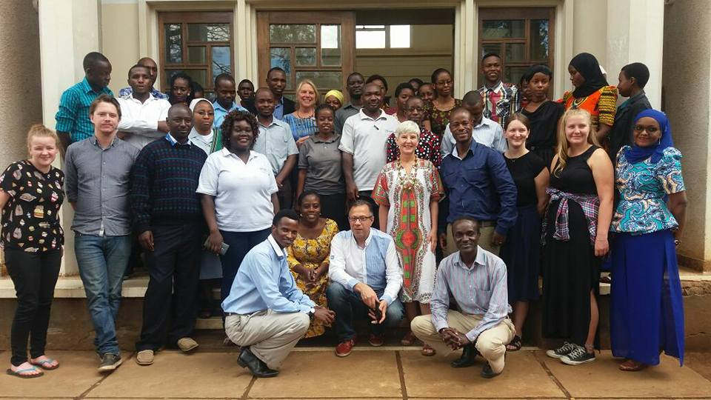
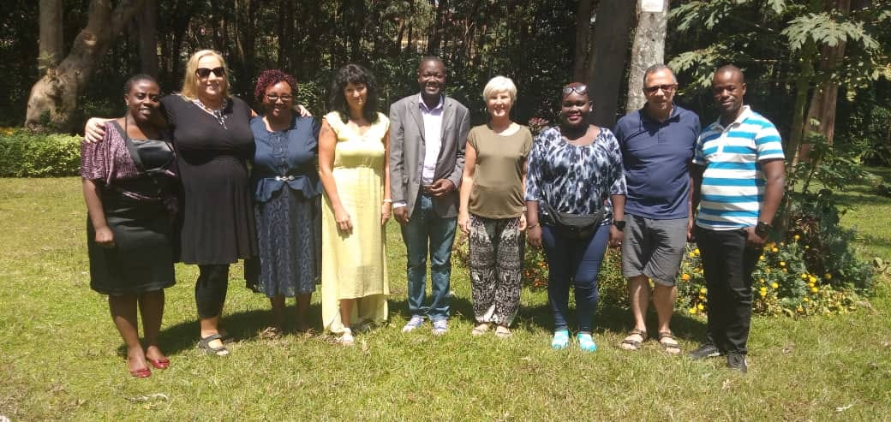
Duncan
(Vice-Secretary)

Contents Page
INTRODUCTION 3
COMMEMORATION OF SOCIAL WORK DAY 2019 3
GENERAL MEETING 4
RECRUITMENT 5
EXECUTIVE COMMITTEE MEETINGS 6
TASWO K INVOLVEMENT IN MARKING NATIONAL EVENTS 6
Mei mosi (May day/International Workers Day) 6
Legal Week 7
INTERNATIONAL SOCIAL WORK CONFERENCE (23TH -25TH OCTOBER, 2018) 8
THE NATIONAL ANNUAL GENERAL MEETING 10
Pre-Conference and Post-Conference activities 10
TRAINEE PROGRAM 11
CONCLUSION 11

INTRODUCTION
This is the activity report form all activities that were accomplished between January 2019 to November/December 2019. TASWO K has continued to do its best in making sure that there is a great success in reaching the objectives, and yearly plans. Activities are captured in the order of how they were implemented. Some photos are included in this report at the start of every activity report section, for illustration purposes.

COMMEMORATION OF SOCIAL WORK DAY 2019
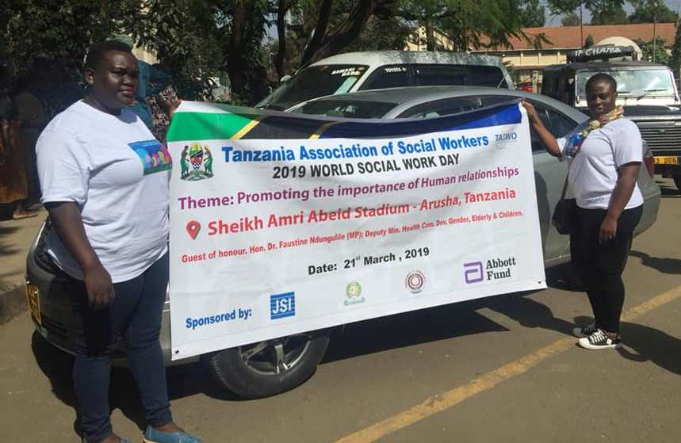
Social work Day-Arusha-21/3/2019
Social Work Day was commemorated on 21 March 2019. This time the National event was marked in Arusha. Fifty (50) TASWO K Members attended Social gathering in Arusha stadium. Also different members from all over Tanzania attended the congregation. In total almost 500 hundred members attended. The Guest of honor was the Commissioner of Social Welfare in Tanzania. There were also National level leaders who are decision makers from the Ministries. Main issues discussed were:
- The updates of social work bill,
- Responsibility of social workers,
- How to deal with work place challenges in social work department and lastly
- Motivation of social works who are not yet members of TASWO to act on it immediately and join.

GENERAL MEETING

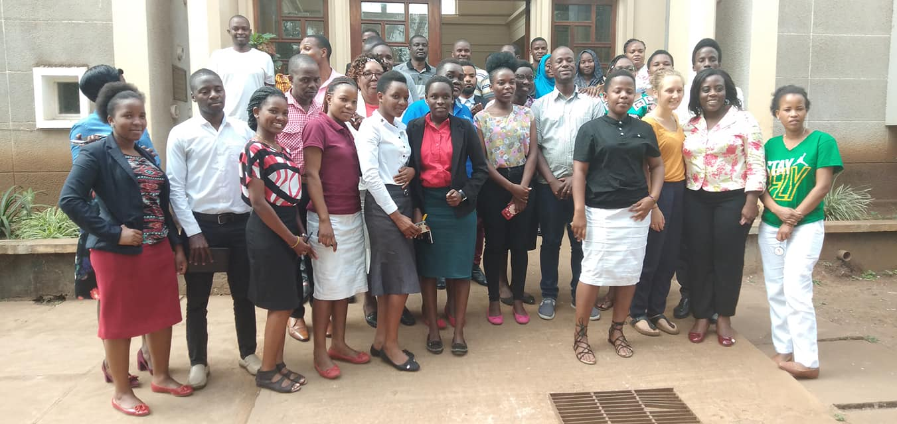
The TASWO General meeting took place on 17/08/2019. In that meeting Mrs. Romana Olomi (the Vice treasurer) was elected as the deputy chairperson of the meeting. Sixty (60) members attended the meeting.
Agenda:
- Opening of the meeting.
- Presentation I: social work club
- Presentation II: Maternal Health services in Kilimanjaro.
- Presentation III: Inclusion of people with disability
- Presentations IV: Updates of TASWO K.
- Presentation V: Election
- Closing Remarks.

Opening of the meeting:
The Delegated chairperson Mrs. Olomi opened the General Meeting by welcoming member and asking them their full participation. The meeting started by introduction where each member was able to introduce him/herself, in group identification the participants were Government officials, Non Governmental practitioners and students from Education Institutions.
Presentations:
Presentation I: MWENGE CATHOLIC UNIVERSITY: SOCIAL WORK CLUB
The first presentation started at 10:00 am presented by the secretary of the Club, this presentation aimed to introduce the Social work club to TASWO K members.
Presentation II: The Second presentation started at 11am by Loveness, a member of TASWO K. Her presentation based on a conducted research to Maternal Health services in Kilimanjaro .In her Report she shows the factors which hinder the deliverance of proper Maternal Health services.
Presentation III. Presented by Upendo Ramadhani.
Her presentation was on Disability inclusion, she urge to all members to take charge on protecting people with Disabilities.
Presentation IV. Updates of TASWO K and highlight of Constitution, Presented by Duncan Mgati
He updated on constitution details to the members of the GM to familiarize the new members and as a reminder to all other members. Keys issues were on core values of TASWO, objectives and function of TASWO.
Election:
The Deputy Secretary Mr Duncan, Provided explanation on the mode of election and he said that since the position announced no new contestant applied for the position. Therefore the majority member voted for the present leaders to proceed for other 3 years.
After the official election, the Deputy Chairperson Mrs Olomi thanked the member for trusting the leadership for giving them a chance to lead but she wanted all members to get involved in professional activities. Meeting closed at 3:45 pm

RECRUITMENT
TASWO K holds recruitment exercise at heart. We clearly believe that the future of a strong social work association depends on young social workers recruited today. In light of the same, 6 Districts and other Government Institutions of Kilimanjaro region were visited. TASWO K managed to recruit new member and about 24 members paid annual subscription this year. The amount of 570,000 collected from member subscription will be located to HQ account as a 50% from member’s annual subscription. The focus was on Non-governmental organizations employing social workers. Currently there are a total of 52 TASWO members.

EXECUTIVE COMMITTEE MEETINGS
This time round, the board had several meetings, much more than it used to be in the past, partly because TASWO K hosted the National TASWO conference and Annual General Meeting (23 to 25 October, 2019). Organizing such big events requires round table discussions, deliberations and coordination from within TASWO K and with our colleagues from TASWO Head Quarters in Dar es Salaam. We also had several pre-preparation meetings for TASWO K General meeting in July, 2019.

TASWO K INVOLVEMENT IN MARKING NATIONAL EVENTS
This was a newly proposed activity this year. The board of TASWO K sought marking these events (International Workers Day and the commemoration of the African Child) would increase TASWO K visibility not only to the society but also in the corridors of powers (government) and amongst other like-minded professions such as Community Development, Law, Teachers etc. As pointed earlier, we limited ourselves to the following:

Mei mosi (May day/International Workers Day)
Internationally, this event was celebrated on 1st May, 2019. In Moshi, the commemoration was hosted at Moshi Cooperative University (MoCU), and the Regional Commissioner (Ms. Anna Mngwira) was invited as the guest of honor. Leaders of National Trade Unions such as TUCTA TALGU and RAAWU delivered speeches focusing the rights and interests of workers in both public and private sector. The key issues that transpired during May day include:
From the Government:
- Motivation and encouragement for workers to work hard in their respective jobs.
From the Trade unions
- The need for better/improved working conditions
- Annual salary increment and extra time allowances. There has not been an increment for the past three and half years in the public sector.
- The need for establishing the confederation of Trade Unions in Tanzania. This move aims to increase workers’ voice and solidarity.

Legal Week
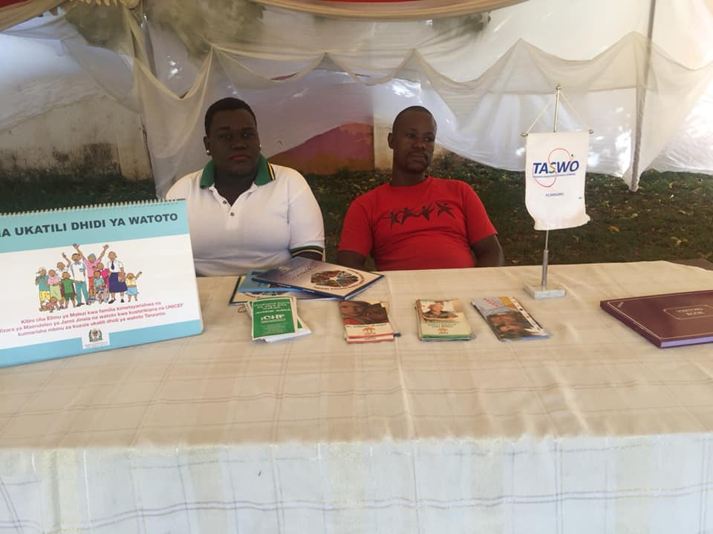
This is usually commemorated by Legal firm officers. TASWO K made deliberate choice to be part of this event due to the fact that Social Welfare services have direct connections with the legal firm on decisions. It was therefore important for TASWO K to participate in order to raise the voice of how the legal firm impacts the provision of social welfare to the needy and the vulnerable populations and improve this collaboration.

INTERNATIONAL SOCIAL WORK CONFERENCE (23TH -25TH OCTOBER, 2018)
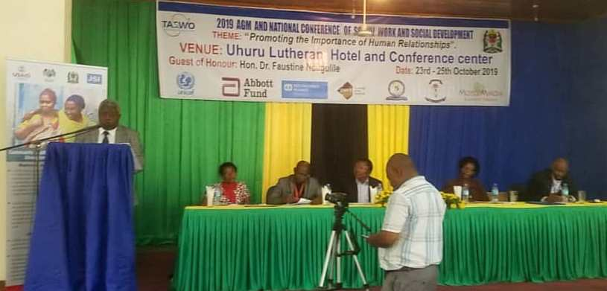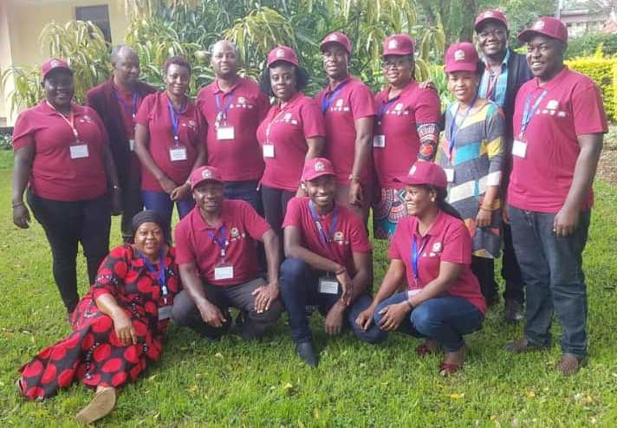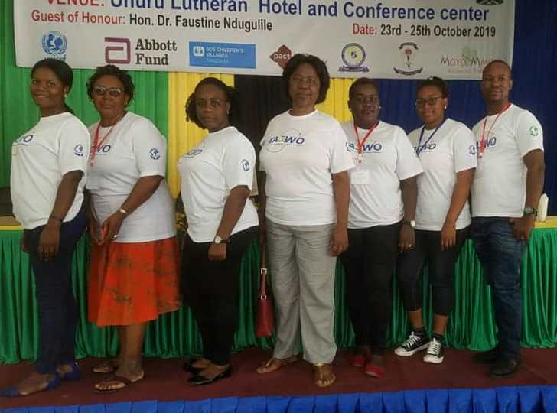
The 2019 international social work conference was hosted by TASWO K –the home of Kilimanjaro. This was the second time for TASWO K to organize and host such a big event which brought at least 160 delegates from within the country, across Africa and Europe –Norway, England and other countries. The conference took place at the auditorium of Lutheran Uhuru Hotel in Moshi. It was guided by the theme: “Promiting Human Relationships.” The conference was graced by Mr. Leonard Mchau, Director of Administration and Personnel at the ministry, who represented Dr. Faustine Ndungulile , Vice Minister of Health, Community Development, Gender, Elderly and Children (MoHCDGEC) in Tanzania. The following is the summary of what he said:
- The ministry will continue to strive to improve the provision of social welfare services to the vulnerable groups. He acknowledged TASWO to have bee working very close with the government in that regard. TASWO and social workers at large are few and therefore having the association is a great move.
- There challenges with lack of the governing law for social work practitioners, however there are other laws that govern the ways the services to the population should be professionally provided.
- With regard to the theme was the importance of human relationships – social welfare services should be accessible. There are people who report their issues to the minister, meaning that these people have no access to the social work services, and this should be looked into.
- He congratulated for social workers to have improved the services to the familie and the society at large. There is a need to focus on the moral decal within the society, and this refers to the challenges with the youths who have lived on the streets and they are turning into becoming street adults.
- He congratulated the pre-conference activities of providing psychosocial services to the youths and children in Moshi. This should be continued also in other areas.
- Challenges:
- He highlighted on the dilemma and collision between social workers and community development workers. There is a need to be practical and realize how much the workforce is needed and present to the minister. Small budget: this is the challenge for every sector. We need to try to use the resources that are available to manage the work. Law: the ministry and the committee are working hand in hand to move it forward and make it a success, we should not forget other law enforcement during our practice.
- Finally, he requested if TASWO could think to organize the conference of this kind on the international level; especially east Africa and south Africa
After the official opening of the conference, a number of presentations were made on Wednesday 23.10.19 and Thursday 24.10.2019. The two days program was focused on Best Practices in various aspects of social work in Tanzania, including issues of child protection, family affairs and vulnerable groups. The presenters were researchers, officials, social work practitioners and academics from various universities and institutions of social work, governmental and non-governmental organizations.

THE NATIONAL ANNUAL GENERAL MEETING
The National Annual General Meeting of the Tanzania Association of Social Workers was organized in connection with the international social work conference. The AGM was on the last day on the conference –Friday 25th October 2019. The AGM was opened by Dr. Mariana Makuu –Chair of TASWO. In her speech, special thanks were addressed to Members for attending the conference. She also thanked the partners for supporting the conference.
Generally, the AGM gave several words of appreciation to TASWO Kilimanjaro Branch for hosting this big event as well as being an active branch with high degree of commitment and dedication. Her speech was followed by the presentation of the annual report, which captured both successes and challenges. Thereafter, treasurer’s financial report was presented followed by debates and discussions.

Pre-Conference and Post-Conference activities
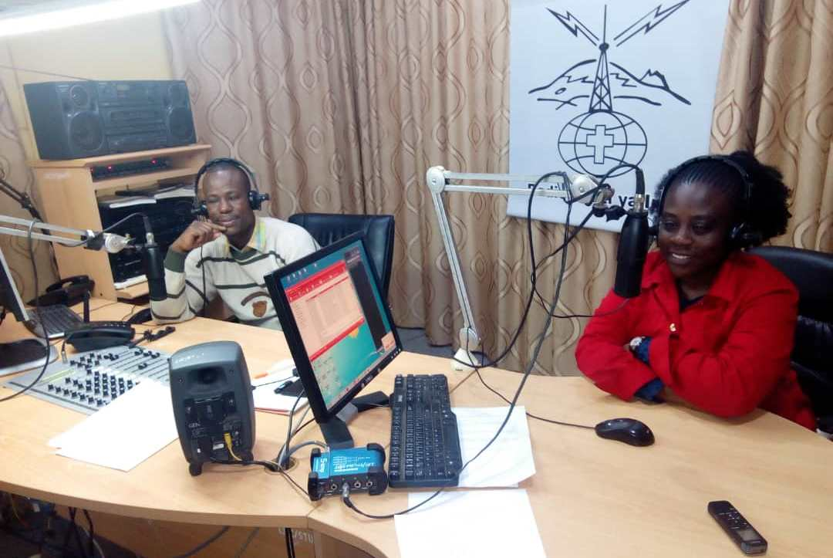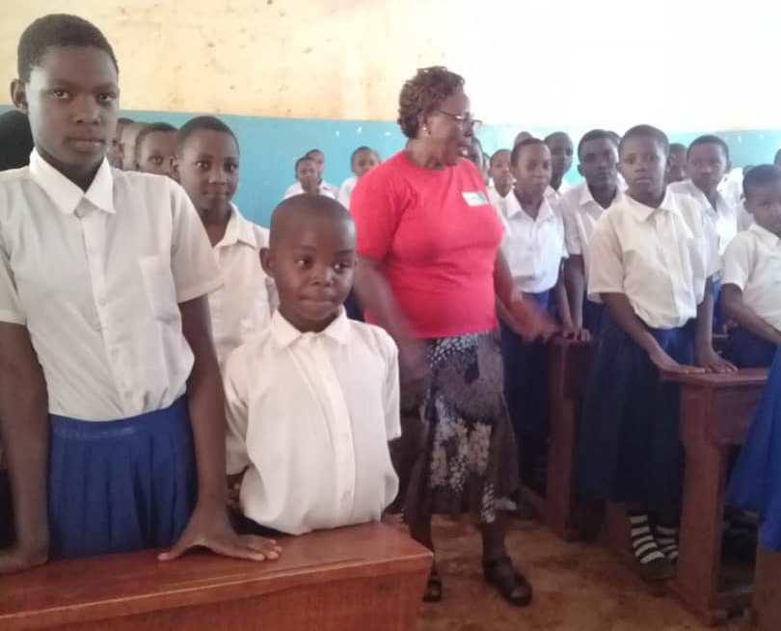
Peculiar for this year, there were decisions by TASWO HQ in collaborations with Branches to have pre-conference activity, in the area where the conference took place. TASWO K therefore hosted these pre-conference activities. The matter that was addressed was the Sexual and Gender Based Violence among Primary school pupils. Six schools in the Moshi Municipal were identified and visited. Sessions with pupils were conducted for two days before the conference. Each school was addressed by a social worker from TASWO K, jointly together with a Member of TASWO from other branches who arrived early in Moshi before the conference. In addition to this, there were also media coverage through the radio in Moshi, where the same topic /matter was shared with the public.
After the conference, TASWO K met to reflect on the Conference in general and discussed the action points that need further actions to advance the work of TASWO. This even was done on the outskirts of Moshi.

TRAINEE PROGRAM
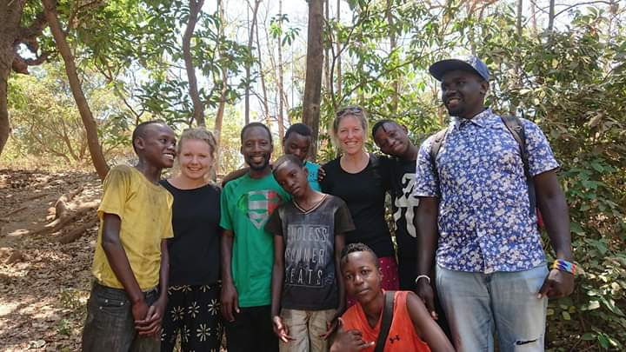
FO Social workers (trainees) were offered an internship at Pamoja Tunaweza Boys and Girls Club in Moshi. They were able to deal with youth program which includes outreach activities (We are looking forward to learn from their report).

CONCLUSION
TASWO K, is very please to see that most of the activities that were planned for this year were implemented. Not only implemented but also with great success. Thanks to all TASWO K members who willingly and voluntarily dedicated their time and energy to make this a reality. Special thanks to FO for providing financial support to TASWO. This continued collaboration between TASWO and FO has a tremendous impact in making TASWO K one of the branches of TASWO in Tanzania that has outstanding records in best achievements.

