

TASWO – KILIMANJARO | ACTIVITY REPORT JAN 2016-NOV 2016
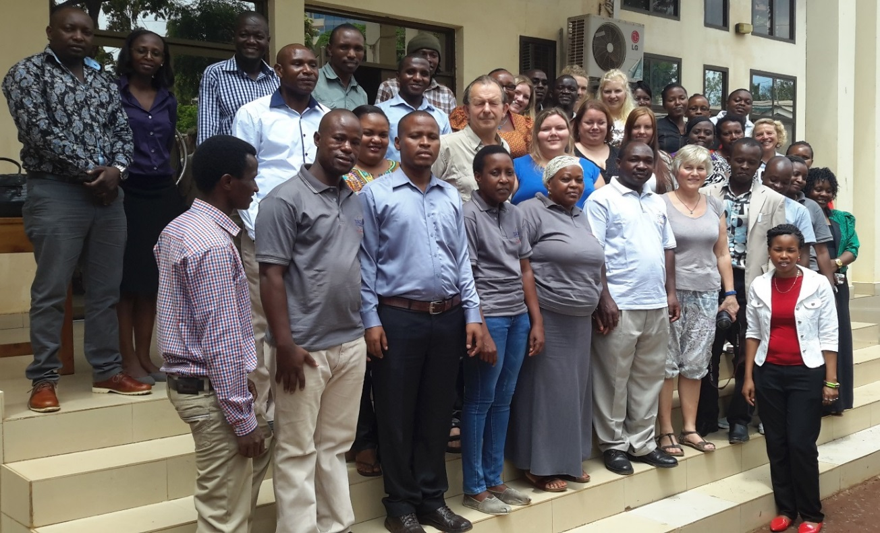

On TOP: Group photo during AGM November 2015, BOTTOM: TASWO K, Executive Committee, with new elected leaders.

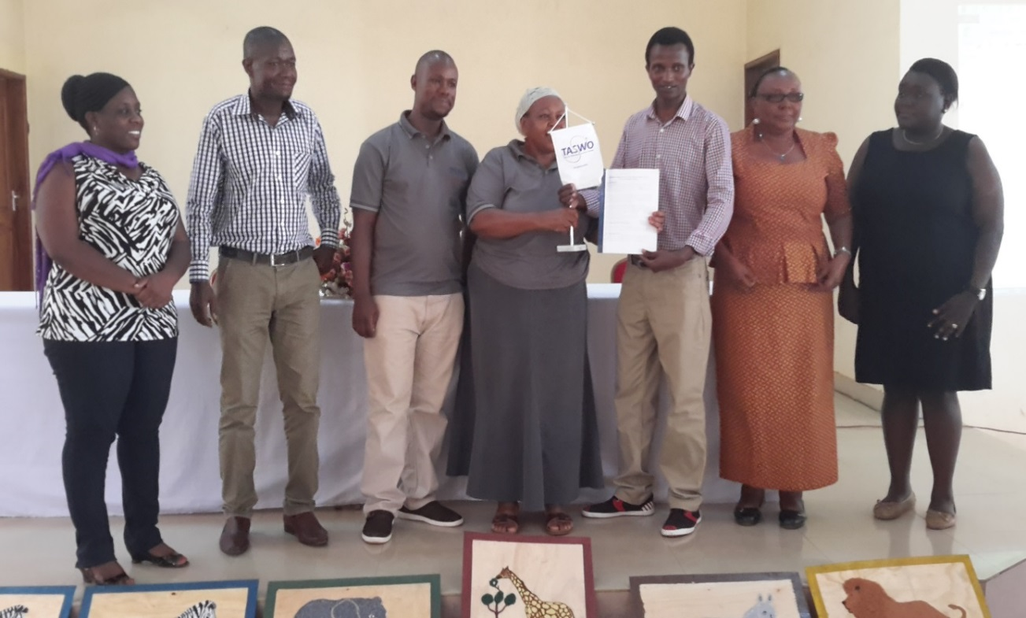
Upendo
(Treasurer)
Japhary
(Secretary)
Duncan
(Vice-Secretary)
Mama Urassa
(Out going – Chairperson)
Sunguya
Chairpeson
Romana
Vice-Treasurer
Magreth
Coopted Member

Report from TASWO Kilimanjaro January 2016- November 2016
0. INTRODUCTION - 2 -
1. TASWO KILIMANJARO - 2 -
2. TASWO K’ ACTIVE MEMBERS - 2 -
3. RECRUITMENT OF NEW TASWO K’ MEMBERS AND WORK PLACE VISITS - 2 -
4. INCOME GENERATING ACTIVITIES FOR TASWO K - 3 -
5. TASWO REPRESENTATIVES - 3 -
6. MEETINGS: - 4 -
6.1 EXECUTIVE COMMITTEE MEETINGS - 4 -
6.2 GENERAL AND ANNUAL GENERAL MEETING - 4 -
6.3 MARKING SOCIAL EVENTS – - 5 -
6.3.1 ‘SOCIAL WORK DAY’: - 5 -
6.3.2 COMMUNITY SERVICE OUTREACH - 5 -
7. EAST AFRICA REGIOANAL CONFERENCE ON SOCIAL WORK AND DEVELOPMENT. - 6 -
8. DELIBERATIONS AT GENERAL &ANNUAL GENERAL MEETING - 7 -

0. INTRODUCTION
This report is covering the period of one year from January 2016 to November/ December 2016 (12 months). It gives the highlights of activities that TASWO K has done in the past 12 months. It also indicates the growth paths that TASWO K is taking. However some challenges that TASWO is still experiencing are also mentioned in this report. Thanks to the funding TASWO is getting from FO because with this funding TASWO is able to commit to implement planned activities. We also acknowledge the contributions from the TASWO Members who have paid their fees, because it has helped in the running of activities and keeping TASWO K active.
1. TASWO Kilimanjaro
TASWO Kilimanjaro is a social workers organisation based in Moshi town, it was established in 2011 with 4 voluntary executive committee members. 2013 TASWO K did an election to elect new secretary and two other members who are assistant treasurer and member to the executive committee which makes the executive committee to have six voluntary members. This is one of the active branch in Tanzania and report to TASWO head quarter in DAR ES SALAAM.
TASWO K did a survey during the work place visit and found out that there are 34 social workers in the Government sector and 27 social workers in other private Institutions. There are 30 prospective students who graduate each year from social work or Community development training Institutions. All these people can subscribe to becoming active members of TASWO K. However currently the number of active members of TASWO K i.e. those who have subscribed to TASWO K this year is 14.

2. taswo k’ active MEMBERS
TASWO K has been growing at the tortoise steps. To give a picture of this growth, the members of TASWO K who were joined/subscribed to TASWO K and paid their dues in 2013 were only 5. in the year 2014 the number only incresed to 7, only 2 social workers joined and who committed to pay their dues. In 2015 TASWO K realizes that the total number of membes who are active and paying their fees is 18. In the year 2016 members who have subscribed to TASWO K is 14. It is the outcome of the opportunities that are there for social workers to meet during events such as Social Work Day. In such events, the TASWO K committee get the chance to mobilize social workers and to talk about different affairs of TASWO, including informing the members about payments of their dues.

3. RECRUITMENT OF NEW TASWO K’ MEMBERS and work place visits
This is an ongoing activity. It involves identification of all organizations and institutions (both public and private) employing social workers in Kilimanjaro region. The following work settings were visited _ Moshi Municipality (social welfare department), Mawenzi Hospital, Regional Administrative Secretary’s office, Moshi Rural District council, KIWAKKUKI and Mwenge Catholic University.
Challenges
- Many social workers and welfare officers are reluctant joining Taswo
- Many of them describes themselves as members of Taswo in different social media groups such as face book and whatsapp but rarely attends meetings or pay their dues
- Associate members (students) after completion of their studies seize to actively participate in Taswo_K activity. Others of course, relocate to the regions of their origin.
- Through this exercise, the committee has a long list of potential members but very few have paid their dues. As a membership organization, one becomes a member by paying annual entry and annual fee and not otherwise.
Way forward
- We shall tirelessly continue to encourage social workers, social welfare officers, practitioners, social educators, researchers, social work students, policy makers etc. (in both Public and Private sector) to see the value of joining Taswo and participate in its activities such as workshops, conferences, seminars, meetings and community service activities.
- We shall get into the roots and contribute meaningfully in facilitating the process of drafting discussion papers on regulating the social work profession for discussions with relevant government authorities. Taswo _K committee strongly believe that to realize a vibrant and sustainable social work profession in Tanzania, Social work council is a must structure that must be brought aboard as soon as possible.

4. INCOME GENERATING ACTIVITIES FOR TASWO K
Currently TASWO K, managed to start the TASWO K’ T- Shirt project. This does not only help is raising funds but also has contributed to make sure that TASWO is known to the public. Social workers purchase the T shirts and also other professionals from other disciplines are also encouraged to support the project. The T-Shirt is printed at TSH 13,000 and is sold at TSH 15,000 the number of T-Shirts that are printed normally is 100 pieces. During the AGM in November 2016 some T-Shirts were purchased by some members. A total of TSH 120,000 was collected after the sale. TASWO K also received the contribution from FO for the sales of T-Shirts at $ 87.32 (sent to TASWO K account). Still members were encouraged to always purchase the T Shirts because it contributes to the growth of TASWO K.

See the sample of TASWO T-Shirts for 2015 - 2016
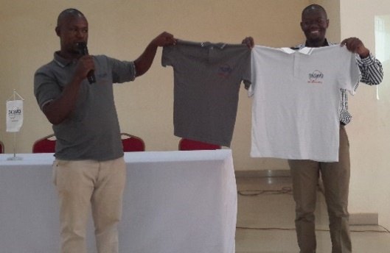

5. TASWO representatives
TASWO K is led by the Executive Committee members, who assume the primary responsibilities to run TASWO K. However for the ease of communication and follow up on membership issues, TASWO leaders have established contacts with respective social workers in specific districts. There are phone numbers and email addresses in our data base and are used to communicate urgent matters as they happen. These representatives can give feedback to TASWO K leaders about any pending or emerging concerns from the members in their areas. (Note: all members are allowed to communicate with TASWO K leaders directly by phone or email or direct visit)
When invitations are sent to invite social workers to the general meeting and Annual general meeting, or any other professional gatherings such as marking social work day, the representatives are informed about the invitations and are asked to follow up and insist members in their respective areas to attend, so they help to ensure that other social workers in their areas are well informed.

6. meetings:

6.1 executive committee meetings
TASWO K, executive committee conducts meeting regularly to discuss different matters of the association. These meetings are either planning meeting, for example before the AGM several meeting are done to prepare the contents and logistics. After the AGM is done an evaluation meeting is organised to look and reflect back on the meeting in order to learn. Each quarter TASWO K executive committee conducts a meeting to discuss various matters pertaining to the association. There are also other extraordinary meetings that are done by executive committee to ensure that TASWO K is active and running its activities.
(Note: Each meeting last between 2 to 3 hours)

6.2 general and annual general meeting
There are two big meetings every year. In April or May depending on a year calendar, there is usually the General meeting. At this meeting, the number of social workers who are expected to attend ranges between 50 and 60. This is the same approximations as for Annual General Meeting which takes place in November every year. The general meeting took place on 23/04/2016 and the AGM took place on 19/11/2016. Number of social workers who attended both meetings is as follow:
S/n | Type of meeting | Number of Attendance | Percentage
1 | General Meeting | 37 | 61.6 %
2 | Annual General Meeting | 48 | 80 %

Important decisions are made and necessary actions for implementation are taken collectively during these two big meetings. In case, the common decisions or at least consensus have not been reached, members are given the opportunity to air out their views and finally the executive committee is given mandate to make executive decisions considering also the input from all the members. Important decisions are captured in a separate report and are communicated to partners in FO. Examples of issues that were treated during the AGM are:
- Presentation of the TASWO K Budget and expenditure report. It was shared to all participants and it was approved ( there were no queries)
- Presentation of the activity report as well as planned activities. Members were happy with all the two documents presented; both activity report and activity plan.

6.3 marking social events –

6.3.1 ‘social work day’:
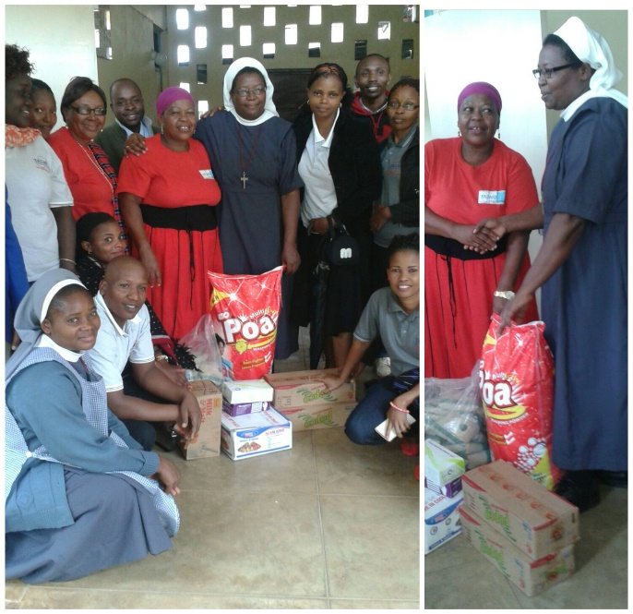
Taswo K celebrated Social workers day on 16th April, 2016, it was a bit late because we had an international conference in Arusha on the social workers day. We organized the event to be marked at Upendo Children’s Home; Upendo is an organization which helps to accommodate the abandoned young kids. We do appreciate the positive response from 21 members who came to attend though it was very raining but they took time to spend with young kids at Center. TASWO K managed to mobilize gifts and collections like sugar, soaps, juice, biscuits and gloves and submit to the Leader of the Center.
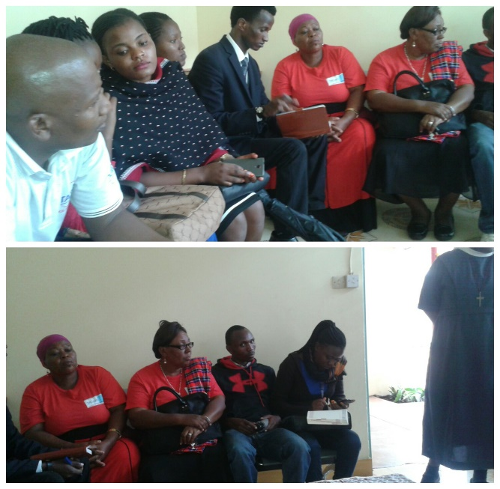

6.3.2 COMMUNITY SERVICE OUTREACH
Two (2) community outreach were organized by Taswo_K
- Visitation to Corlnel Kaleku Orphanage Home in Rombo district on Saturday 14. 04. 2016
- Visitation to Upendo Children Home in Moshi Municipality on Saturday 23. 07. 2016
Nature of the activity _ community service (outreach programme)
Organizers _ Executive Committee Taswo _Kilimanjaro in collaboration with the community service members from Mwenge Catholic University, Moshi Tanzania.
Strategy _whatsApp group, M_Pesa, Airtel Money and TiGO Pesa
Activities involved planning, fund rising (resource mobilization), and conducting needs assessment to establish the reel needs of children in residential homes.
Description of the activity
Through fund rising (an activity which involved both members and good wishers and friends of Taswo_K, together with the community members from Mwenge Catholic University) we managed to collect one million, one hundred sixty five and two fifty thousand only (1, 165,250 Tshs). Members were asked to donate anything worthy for children. They were free to donate either money, material or both. They all made our community service a success. We are happy and proud that Taswo _K through its committed members have managed to restore a smile on children faces. The committee managed to procure the following items
- 125 kgs of rice
- 115 kgs of maize flour (Sembe)
- 100kgs of sugar
- 100 liters of cooking oil
- Four (4) dozen of lactogen (infant care)
- Powder soap 100kgs
- two dozen of Bar soap
- Shoes, clothes, and games for children (there were enough donations).
- Soft drinks and drinking water, biscuit and sweets for children
- 150, 000 Tshs cash was given to each Orphanage center
Members presents had an opportunity to socialize and play with children.

7. eAST AFRICA REGIOANAL conference on social work AND DEVELOPMENT.
The 3rd East Africa Regional Conference on Social Work and Development 15th _ 17th March 2016, Arusha Tanzania
Organized and sponsored by
- Tanzania Social Workers Association
- Austrian Partnership Pogramme in Higher Education and Research for Development (APPEAR)
Host country_Tanzania (United Republic)
Invited countries _Tanzania Isles (Zanzibar), Kenya, Uganda, Rwanda, Burundi, Ethiopia and Austria
Participants were social work practitioners, social welfare officers, social and community educators, researchers, policy makers, social scientists etc
Taswo_K was represented by Francis Sunguya (Chairman), Ibrahim Ally (member), Christina Haule (member) and mama Urassa (former chairpeson). Participation fees was 150,000 Tshs for each member.
Guest of Honor _ Hon. Ambassador Augustine Maiga (The Minister for East Africa, Regional and International Relations)
Main agenda
- Marking international Social work day. This was a colorful event which took place on 15th March 2016. Participants matched through the streets of Arusha city and thereafter several speeches were made at Sheikh Amri Abeid Stadium. Remarkably the speech delivered by the Commissioner for Social Welfare and the President of Schools of Social Work in Africa who called participants from each country to facilitate the process of drafting discussion papers on regulating the social work profession for discussions with relevant government authorities.

- Conference resolutions 16th _17th March, 2016.

Following several presentations and the discussions thereafter, the following resolutions were reached
- Conduct research on the role of social work in poverty reduction towards achieving the Millennium Development Goals,
- Strengthen the capacity of higher social work education institutions in the region through research, curriculum development and joint publications. The focus being indigenization of African knowledge, models and approaches in Social work training in Africa.
- Develop sustainable academic partnerships and networks in social work training and research in Africa and internationally,
- Facilitate the process of drafting discussion papers on regulating the social work profession for discussions with relevant government authorities. This was necessary for the realization of Social work council in each county and across the region.

8. deliberations at General &ANNUAL general MEETING
For a long time we have had member of TASWO who do not pay their dues. This is not good for the growth of TASWO K. The resolution was made during the AGM that only members that have paid their dues will be invited to the AGM no matter how few they are. The rest of the members will attend as observers if they wish, but also they will be informed of the contributions they have to make to meet the meeting running costs such as food and registration, and only those who will abide to that condition will be allowed to come to the meeting.
Another resolution is for TASWO K to organise conferences or workshops for active members. This activity will be done separately from the normal TASWO K – FO Budget. TASWO K will work hard to mobilize resorces from within, and will also contact FO for support.

